

**BALLYMENA ACADEMY**

**Addressing Bullying Policy**

**POLICY REVIEWED MAY 2024**

**Policy ratified at August 2024**

**B of G Meeting**

**Due for Review : May 2028**

Ref. Addressing Bullying Policy (Reviewed May 2024)

**BALLYMENA ACADEMY**

**ADDRESSING BULLYING POLICY**

**Introduction**

At Ballymena Academy we believe that the safeguarding of all our pupils is paramount, and that this policy supports our work in creating a secure and caring environment. We believe that everyone in our school community has a role to play in creating a safe, inclusive, and welcoming environment for all. We acknowledge that bullying type behaviour exists in all school communities and the wider society. Therefore, we seek to provide an open climate where pupils, staff and parents are free to talk about, and address these behaviours in a supportive manner. Our aim is to embed and develop a culture where bullying type behaviour is not tolerated.

The purpose of this policy is to define bullying type behaviour, outline roles and responsibilities, clarify the preventative curriculum, highlight processes for reporting, explain recording formats and depict effective responses to bullying type behaviour. ​

Bullying type concerns relating to school staff, other staff or parents is managed through:-

* our visitor's policy,
* TNC 2009/11 Policy and Procedure to combat Bullying and Harassment of Teachers.

If there is dissatisfaction with the school response regarding a bullying type concern, complaints should be managed in line with the school’s complaints policy accessible on the school website.

**Aim**

To promote a supportive, caring and safe environment for pupils in which they will have no fear of being bullied.

**Principles**

* The organisation of the school positively supports the maintaining of a caring community which promotes tolerance, mutual respect, courtesy, thoughtfulness and kindness.
* The school seeks to ensure a high degree of collective vigilance in order to minimise opportunities for bullying type behaviour involving a registered pupil at the school on the premises of the school during the school day, while travelling to or from school during the school term, while the pupil is in the charge of a member of staff or while the pupil is receiving educational provision arranged on behalf of the school and provided elsewhere than on the school premises.
* Members of the school community should be aware of the

1. types and causes of bullying type behaviour;
2. signs of bullying type behaviour; and
3. established procedures for dealing with incidents of bullying type behaviour.

[These matters are addressed in the guidelines made available to pupils, staff and parents.]

* Established procedures are followed where the school has been alerted to possible incidents of bullying type behaviour.
* The school seeks to create and maintain a climate where pupils, parents and staff feel confident that any complaints of bullying type behaviour are taken seriously.
* The school seeks to ensure that any complaints of bullying type behaviour are dealt with promptly, consistently, sensitively and, where possible, discreetly.
* The school records, through Senior Staff and Heads of Year, details of incidents of bullying and alleged bullying type behaviour using appropriate Management Information System (MIS) which refers to motivation, method and how the incident was addressed, together with the outcomes. These are recorded on the Bullying Concern Assessment Form (BCAF).
* Parents are made aware of the school’s Addressing Bullying Policy.
* A close working partnership between home and school is encouraged in the prevention, detection and reduction of bullying type behaviours.
* The school provides support and opportunity for counselling of both the pupil experiencing bullying type behaviour and the child who is displaying bullying type behaviour.
* The aim of all action is to stop the behaviour and support all the pupils involved.
* It is the responsibility of the Board of Governors, in liaison with the Principal, to monitor the effectiveness of the Addressing Bullying Policy. To this end, the Board of Governors will:
* maintain a standing item on the agenda - incidents of bullying type behaviour will be noted.
* identify trends and priorities for action.
* assess the effectiveness of strategies aimed at preventing bullying type behaviour.
* assess the effectiveness of strategies aimed at responding to bullying type behaviour.
* The Board of Governors is informed of preventative activity and reported concerns.

This policy is part of the wider school approach to safeguarding, through consultation with pupils, parents and pastoral staff.

It is a legal requirement that the Addressing Bullying Policy be reviewed at intervals of no less than four years and following any serious or significant incident, which highlights the need for such a review. It must also be reviewed when directed to by the Department of Education following new guidance. As such, the Addressing Bullying Policy will be reviewed as required, in consultation with the school community, on or before May, 2028.

Ref. Addressing Bullying Guidelines Pupils & Staff Reviewed May 2024

**Guidelines for Addressing Bullying Type Behaviour**

|  |  |
| --- | --- |
| **Pupil Guidelines**  **Introduction**  **Bullying type behaviour of any kind is totally unacceptable and has no place in this school.** We want all pupils to feel that our school is a caring, friendly and safe place to be.  You have the right to feel safe in school, and on the way to and from school.  All staff and pupils alike should | |
|  | * treat others as they would like to be treated; * accept that not everyone is the same; * speak in a way which does not offend or harm others; and * behave in a way which is neither threatening nor hurtful. |
| **1.1** | **What is bullying type behaviour?**  ‘Bullying includes but is not limited to the repeated use of any verbal, written or electronic communication, any other act or any combination of those, by a pupil or group of pupils against another pupil or groups of pupils, with the intention of causing physical or emotional harm to that pupil or group of pupils.’ Addressing Bullying in Schools Act (NI) 2016  The following list is **not exhaustive** but bullying type behaviour can take forms such as:   1. **Physical**: pushing, kicking, hitting, punching, physical intimidation, use of items as a weapon and any other forms of violence, or threats of the same. 2. **Verbal**: name-calling, sarcasm, spreading rumours, insults, persistent teasing, jokes, abusive or threatening notes/social media messages/phone calls. 3. **Emotional/Social**: tormenting, humiliating, socially excluding, spreading rumours, manipulating situations, controlling behaviour. 4. **Sexual propositioning**: unwanted physical contact, abusive comments, sexting, or vulgar gestures. 5. **Prejudicial**: taunts, graffiti or gestures based on race, disability, religion, political views or sexual orientation. 6. **Damage to property or theft**: clothing, school books or other personal property may be hidden, damaged or stolen. 7. **Electronic communication:** use of technology to harass, hurt, threaten, embarrass or target, impersonating someone online to cause hurt, sharing images online to embarrass someone. Cyber bullying can occur anytime, anywhere, the audience can be large and involved quickly and the scale of consequences of actions can be unintentional. |
| **1.2** | **Why do people display bullying type behaviour?**  Some people display this type of behaviour because they   * like the feeling of power and like to impress; * are unable to accept difference; * are selfish, arrogant or spoilt and expect everyone to do what they say; * feel insecure, inferior, humiliated or lonely; * have been abused and/or have experienced bullying type behaviour themselves; * are under pressure to succeed at all costs; * do not fit in with the other pupils; * feel no sense of achievement; * have problems within their home environment; * are jealous, through low self-esteem or selfish ambition; * allow themselves to be pressurised by their peer group. |
| **1.3a**  **1.3b** | **The effects of bullying type behaviour**  Bullying type behaviour can result in   * insecurity, sadness, loneliness; * loss of confidence and motivation; * depression or anxiety; * low self-esteem; * shyness, being withdrawn; * poor academic achievement; * isolation, and * self-harm, threatened or attempted suicide.   **Other signs could be**   * belongings lost/stolen; * unexplained injuries; * fear of school or truancy; * requesting or stealing money; * changes to sleep and eating patterns, * physical and mental health complaints; * poor attendance; * displaying bullying type behaviour towards others. |
| **2.** | **What to do if you are experiencing bullying behaviour**   * Tell someone you can trust, e.g. a parent, a teacher, a friend or a relative. Do not keep it to yourself. Remember that your silence empowers the person displaying the bullying type behaviour . * If you feel the need, ask a friend to come with you to talk to an adult, or ask your friend to talk to an adult on your behalf. * Always be honest and factual - do not exaggerate. * Tell yourself that you do not deserve to experience this behaviour and that it is wrong. The person/s acting in this way need to change - not you. * Be proud of who you are. It is good to be individual. * Try not to show that you are upset - a person displaying bullying type behaviour thrives on someone’s fear. * Stay with a group of people if you are anxious about being alone. There is safety in numbers. * Try being assertive. Walk away and go straight to someone you trust - a friend, a teacher or member of staff. * You could call CHILDLINE (Tel. 0800 1111) or use their online support at www.childline.org.uk. They provide a 24-hour confidential counselling service for young people in trouble or in danger. Calls are free and do not show up on your phone bill. * **You will be taken seriously and every effort will be made to stop this bullying type behaviour.** |
| **3.** | **What to do if you suspect someone is experiencing bullying type behaviour**   * If a fellow pupil shows some of the following signs, they may be experiencing bullying type behaviour: * fear of making the journey to or from school, * becomes withdrawn or isolated, * anxiety about personal safety, * school work suddenly becomes worse, * damage to property or clothes, * stops eating, * cries more easily, * becomes unusually aggressive, * starts borrowing money, * unexplained bruises, scratches, cuts, * absence(s) from school.   If you suspect that someone is experiencing bullying type behaviour:   * TAKE ACTION! Seeing it happen and doing nothing looks as if you are on the side of the person displaying the bullying type behaviour. If you do nothing to stop it, then you share the responsibility for someone else’s unhappiness. * If you feel you cannot get involved, tell someone you can trust **immediately**, a parent, teacher, friend or relative. Do not keep it to yourself. * Do not side with anyone who is displaying bullying type behaviour. |
| **4.** | **Action taken**  Bullying type behaviour is serious and any reported incident will be thoroughly investigated and recorded. We assure you that support and, if needed, counselling will be given. Action will be taken in accordance with the school’s Addressing Bullying Policy, or other relevant policies in the Safeguarding and Pastoral suite of policies. |

|  |  |  |
| --- | --- | --- |
| **Staff Guidelines**  **Introduction** | | |
| The school is committed to providing a positive, caring, friendly, supportive and safe environment for all pupils so that they can learn in a relaxed and secure atmosphere where bullying type behaviour is less likely to occur, either in or outside the classroom. Bullying type behaviour of any kind is totally unacceptable and has no place in the school.  Everyone has the right to feel safe in school, and on the way to and from school. The school provides advice about safe and appropriate behaviour online.  It is the responsibility of all staff, and pupils alike, to | | |
|  | | * treat others with respect, courtesy and kindness; * respect each other’s individuality; * express opinions in a manner which does not offend or harm others; and * behave in a manner which is neither threatening nor hurtful.   Staff are also expected to   * provide positive role models in terms of interpersonal relationships with pupils, * use teaching materials which do not give a negative view of any group because of their race, religion, sexual orientation, disability or political views, * use the tutor group/assemblies/Personal, Social and Health Education (PSHE) programme to discuss aspects of bullying and the appropriate way to behave, and what friendship really is, * counteract bullying type behaviour when they become aware of it, * report incidents, suspicions or concerns. |
| **1.1** | | **What is bullying type behaviour? (See Pupil Guidelines)** |
| **1.2** | | **Why do people display bullying type behaviour? (See Pupil Guidelines)** |
| **1.3** | | **The effects of bullying type behaviour (See Pupil Guidelines)** |
| **2.** | | **Recognising possible signs in a pupil experiencing bullying type behaviour**  A pupil may indicate by signs or behaviour that he or she is experiencing bullying type behaviour. Members of staff should be aware that the following are possible signs and that they should investigate if a pupil   * is frightened of walking to or from school, * has unexplained physical injuries, * is unwilling to come to school, * begins to do poorly in school work, * becomes withdrawn, or starts stammering, * regularly has books or clothes damaged, * becomes distressed and anxious, and stops eating, * cries easily, * becomes disruptive or aggressive, * “loses” possessions and/or money, * starts stealing money (to pay bully), * is too frightened to tell what is wrong, or * runs away, self-harms or attempts suicide. |
| **3.** | | **Procedures for dealing with incidents of alleged bullying** |
| **3.1** | | Pupils are encouraged to report any incident of alleged bullying to a member of staff. The member of staff will investigate and deal with the matter directly and/or inform the tutor, Pastoral Adviser or Head of Year (HOY) according to the seriousness of the incident. The Head of Year must be informed, even when he/she does not need to be involved in dealing with the incident, so that a detailed, central record can be kept. The Head of Year will, where necessary, keep the Vice-Principal in charge of Pastoral Care and the Principal fully informed. |
| **3.2**  **3.3** | | **Responding to and Recording a Bullying Concern**  Concerns raised will be responded to using the legislative flow chart and will be assessed against the legal definition using the Bullying Concern Assessment Form part 1 and 2.  If the legal definition and criteria are met, the school will proceed to part 3 of the Bullying Concern Assessment Form with supports and interventions. The effectiveness of the supports will be monitored through the completion of the Bullying Concern Assessment Form part 4.​  If, however, on investigation, the incident reported does not meet the legal definition having completed the Bullying Concern Assessment Form part 1 and 2, support will be implemented via the positive behaviour policy and the suite of pastoral, safeguarding and SEN policies.​  Digital records of the Bullying Concern Assessment Form will be stored securely within the school’s C2K folders. Access to these records will be restricted and only provided to those members of school staff with a legitimate need to have access. The Principal / Deputy Principal will have oversight of these records.  All records will be maintained in line with relevant data protection legislation and guidance and will be disposed of in line with the school’s Retention and Disposal of Documents Policy. Collated information regarding incidents of bullying and alleged bullying behaviour will be used to inform the future development of anti-bullying policy and practice within the school.  **When dealing with an incident of bullying type behaviour the following steps should be taken:-**  Staff should adopt a positive mind set when responding to a bullying concern.   * Remain calm; you are in charge and it is important to be clear thinking. Reacting emotionally may give control of the situation to the child who is displaying bullying type behaviour. * Reassure the pupil who has experienced bullying type behaviour ~~t~~hat the matter is being taken seriously, and that it will be dealt with promptly and sensitively. * Interview the pupil, alleged pupils and witnesses separately and keep a detailed written record. * Inform and involve both sets of parents where necessary, so that they may support their children and the school. * Offer concrete help and advice to the pupil who has experienced bullying type behaviour. * Be positive – have in mind the importance of maintaining positive relationships. A pupil is more likely to modify behaviour if they perceive care. * Make it plain to the pupil displaying bullying type behaviour that you disapprove of his/her behaviour; be assertive. * Provide ongoing support and opportunity for counselling of both of the pupils. If possible, both should meet together with a member of staff to talk through the situation, and come to an acceptable resolution. * Decide on appropriate action to be taken in accordance with the school’s positive behaviour policy. * Explain clearly the intervention and sanction and why it is being given. Take care not to react aggressively or punitively in case you give the message that it is all right to display such bullying type behaviour if you have the power. * Assess the situation and its severity and how it conforms to the policy definition of bullying. Ensure that the HOY is kept fully informed. Depending on the identified severity level, an appropriate level of response will be determined by the HOY to manage the situation effectively, investigating and recording. * Inform colleagues if the incident arose out of a situation in which everyone should be vigilant. * Hold a follow-up meeting with parents to report progress, and to reassure them that the incident will neither linger on nor be held against anyone. * Keep a detailed, written record of incident, interviews and action. The Record, using the Bullying Concern Assessment Form (BCAF), should include: determining the nature of the behaviour, specific details of the incident or incidents the frequency including times and locations and duration. * The success of the actions should be routinely monitored, reviewed and amended as required in response to developing need.   **DISCRETION:**  The 2016 Act requires schools to consider the following when assessing whether an incident/s meet the legal definition of bullying type behaviour:   * pupil/s capacity to understand the impact of their behaviour. * developmental age * Additional needs, SEN, behaviours displayed (diagnosed or undiagnosed e.g. SBEW, ASD, FASD, MLD etc.) * Individual challenges e.g family circumstances, trauma etc * Levels of resilience.   All behaviour should be regarded as a form of communication and will be regarded as such when addressing instances of unacceptable/bullying type behaviour. We will address all incidents in a non-judgemental, relational, solution focused manner aligned to Safeguarding and SEND. |
| **3.4** | | **When dealing with an incident of bullying type behaviour some things should be avoided.**  Do not   * be over-protective and refuse to allow the pupil who has experienced bullying type behaviour to help him/herself; * assume that the child who is displaying bullying type behaviour is bad through and through: try to look objectively at the behaviour with the pupil; * try to hide the incident from the parents of either of the pupils; * call in the parents without having a constructive plan to offer each side.   **A high degree of collective vigilance, both inside and outside the classroom, is needed for the prevention, detection and elimination of bullying** type **behaviour.** |
| **Advice to Parents**  **Introduction**  The school is committed to providing a caring, friendly and safe environment for all pupils so that they can learn in a relaxed and secure atmosphere. Bullying type behaviour of any kind is totally unacceptable and has no place in the school.  Everyone has the right to feel safe in school, and on the way to and from school.  A close, working partnership between home and school is encouraged in the prevention, detection and elimination of bullying type behaviour. | | |
| **1.1** | **What is bullying type behaviour? (See pupil guidelines)** | |
| **1.2** | **Why do people display bullying type behaviour? (See pupil guidelines)** | |
| **1.3** | **The effects of bullying type behaviour (See pupil guidelines)** | |
| **2.** | **Recognising possible signs in a pupil experiencing bullying type behaviour**  A child may indicate by his/her behaviour that he/she is experiencing bullying type behaviour. If your child shows some of the following signs, bullying type behaviour may be occurring, and you may want to ask if someone is displaying bullying type behaviour towards them.  Children may   * be frightened of walking to or from school, * change their usual routes, * not want to go on the school bus, * beg you to drive them to school, * be unwilling to go to school (they may even be school-phobic), * feel ill in the mornings, * begin truanting, * begin to do poorly in their school work, * come home regularly with clothes or books destroyed, * come home starving (lunch has been taken) * become withdrawn, start stammering, lack confidence, * become distressed and anxious; stop eating, * start self-harming or attempt or threaten suicide, * cry themselves to sleep; have nightmares, * repeatedly “lose” their possessions and/or money, * ask for money or begin stealing money (to pay someone), * refuse to say what is wrong (too frightened to explain physical injuries), * have unexplained bruises, scratches, cuts, * begin to display bullying type behaviour towards other children or siblings. * become aggressive and unreasonable, or * give improbable excuses to explain any of the above. | |
| **3.** | **What to do if you are concerned your child may be experiencing bullying type behaviour**  If you are worried about your child   * do not ignore the problem. * encourage your child to talk to you about his/her feelings - tell your child that you are always willing to listen, and that you want to help and support him/her whatever the problem is. * take whatever your child says seriously and find out exactly what has been going on. * try not to over-react, even if you are furious - it may frighten your child into silence, and children who are experiencing bullying type behaviour should be encouraged to talk, not retreat. * do not promise to keep the information secret, but reassure your child that you will help him/her sort out the problem. * be positive and reassure him/her that the bullying type behaviour is not his/her fault and make sure that he/she feels protected. * discuss possible ways of changing the situation, and try to minimise opportunities for bullying behaviour * advise your child not to resort to the same tactics as the child who is displaying the bullying type behaviour since that can make matters worse. * build up his/her self-confidence with plenty of praise and affection. Encourage him/her to do something he/she is particularly good at. * encourage your child to develop new hobbies or interests which may lead to a supportive group of friends, both in and out of school. * take any threats of suicide or other desperate pleas seriously and seek help-better safe than sorry. Young people sometimes go to extremes if they are miserable. It is vitally important that the school is made aware of any such circumstances. Any information given in this regard will be treated in the strictest confidence. * try to sort out the issue at first as quietly and constructively as possible.   If your child is experiencing bullying type behaviour through electronic communication:   * get them to show you the messages and tell you at once if anything new happens. * tell them never to respond to cyber-bullying or to abusive texts or the like * make sure they only use moderated chatrooms * tell them that bullying type behaviour usually stops once they tell other people * if bullying type starts in a chatroom, tell them to leave, inform you and the moderator. * tell them to never give out contact details or photographs of themselves on websites/chatrooms.      * In addition report your concerns to the school, giving opportunity and time for the school to explore the concern fully and respond appropriately:  1. Contact the Head of Year immediately and discuss the problem. If necessary, request a meeting and provide detailed background information. Your complaint will be taken seriously and appropriate action will follow. 2. Arrange a follow-up appointment to discuss both the results of any investigations, and the outcomes. 3. Try to give the situation time to change. 4. If there is no improvement, make an appointment to see the Principal. If you feel that the alleged bullying incident is very serious, you may wish to speak to the Principal at the outset. | |
| **4.** | **What to do if your child is displaying bullying type behaviour** | |
| **4.1** | If you learn that your child is displaying bullying type behaviour   * Try to stay calm. * Try not to become angry and defensive. * Ask exactly what your child has been doing. * Ask if he/she has behaved like this before.   Talk to teachers, and to other parents. The more you can find out about what has been going on, the easier it will be to work out why your child has been displaying bullying type behaviour, and what can be done about it. It is in their best long-term interest and that of the child who is experiencing bullying type behaviour that the issue is dealt with. Make contact with the appropriate pastoral staff in school. The school will then provide support. | |
| **4.2** | **Helping your child to stop bullying type behaviour**   * Ask your child if he/she can explain what has happened, and why - try not to be too judgmental at this point. * Reassure your child that you still love him/her - it is his/her behaviour you disapprove of. * Try to ascertain the nature, frequency and duration of the bullying type behaviour. * Talk with your child and find out if there are ways you can work together to stop his/her behaviour. * Explain that the bullying behaviour must stop, and that the situation may become worse if it does not. * Explain how frightening the bullying type behaviour is for the victim, and try to encourage empathy. * Work out a way for your child to make amends for the bullying type behaviour * Tell your child that you know he/she can change the bullying type behaviour. Give your child the confidence to try to change. * Look for good behaviour from your child and praise it when it occurs. Create opportunities for him/her to shine. * Set limits. Stop any show of aggression immediately, and help the child find other, non-aggressive ways of reacting. * Explain that getting away from a situation where he/she can feel himself/herself losing his/her temper, or things getting out of hand, is not weakness. It is a sensible way of ensuring that the situation does not get worse. * Try to spend as much time with your child as you can, especially listening to his/her concerns. Sometimes children bully other children as a way of getting attention. * Make it clear that you do not accept bullying type behaviour, and that there will be consequences at home, such as loss of privileges, if the bullying type behaviour does not stop. * Talk to the school staff. Explain that your child is making an effort to change his/her behaviour. Ask what ideas they have to help.   Parents can help by controlling their own response, and by making it clear that any kind of bullying type behaviour is always unacceptable.  The school provides support and opportunity for counselling of both pupils who are subject to bullying type behaviour and to those who display bullying type behaviour. | |

**Appendix 1**

To assess whether an allegation meets the legal definition of bullying type behaviour, schools must understand the difference between bullying type behaviour and socially unacceptable behaviour.

Socially unacceptable behaviour becomes bullying type behaviour when the following criteria have been met:-

Is the behaviour :- targeted

repeated

intentional

causing psychological or physical harm

**All 4 must be met to define bullying type behaviour.**

**Targeted** - it is when someone seen with lesser power is identified as an object of negative attention, for example, targeted due to appearance, race, gender, special educational need.

**Repeated** - refers to identifying methods of behaviour which are repeated towards the same targeted person over a period of time.

**Intentional** - is it to intentionally cause harm?

* Do pupils have the capacity to regulate and understand the impact of their behaviour?

* Age of pupils involved

* Are there any individual challenges, for example, family trauma, circumstances.

* What are the levels of resilience?

**Psychological or Physical harm** - schools must assess if psychological or physical harm has been caused.

- Psychological harm is distress or anxiety intentionally caused by scaring, humiliating or affecting a pupil's self-esteem, social behavioural or emotional wellbeing.

- Physical harm is intentionally hurting a pupil causing injuries such as bruises, broken bones, burns or cuts.

**A one-off incident**

The legislation acknowledges that a **one-off incident** may be considered as bullying type behaviour pending the - severity of the incident

- evidence of pre-meditation

- significant level of impact on school community

For example, where a digital communication has been intentionally shared widely to cause harm.

Schools must address all incidents in a non-judgemental, positive, relational, solution focused manner.

**Appendix 2**

**Methods & Motivations of Bullying Type Behaviour**

Individuals who display bullying type behaviour may have various methods and motives. Some examples are, but not limited to:

|  |  |
| --- | --- |
| **Methods** | **Motivations** |
| **Physical (**includes for example: jostling physical intimidation, interfering with personal property, punching/kicking)  Any other physical contact (which may include use of weapons)  **Verbal** (includes name calling, insults, jokes, threats, hurtful comments, spreading rumours)  **Social** (includes group manipulation, individual manipulation, controlling behaviour)  **Indirect** (includes omission, isolation, refusal to work with/talk to/play with/help others)  **Electronic** (through technology such as mobile phones and internet) | * Ability  * Age  * Appearance  * Looked After Child LAC/ Care experienced  * Community background  * Cultural  * Disability  * Economic status  * Family circumstances (pregnancy, marital status, young carer status  * Gender/Gender identity/Perceived gender  * Newcomer/Migrant status  * Peer relationship breakdown  * Political affiliation/sectarianism  * Pregnancy  * Race  * Religion  * SEN  * Sexual orientation  * Other |

**Appendix 3**

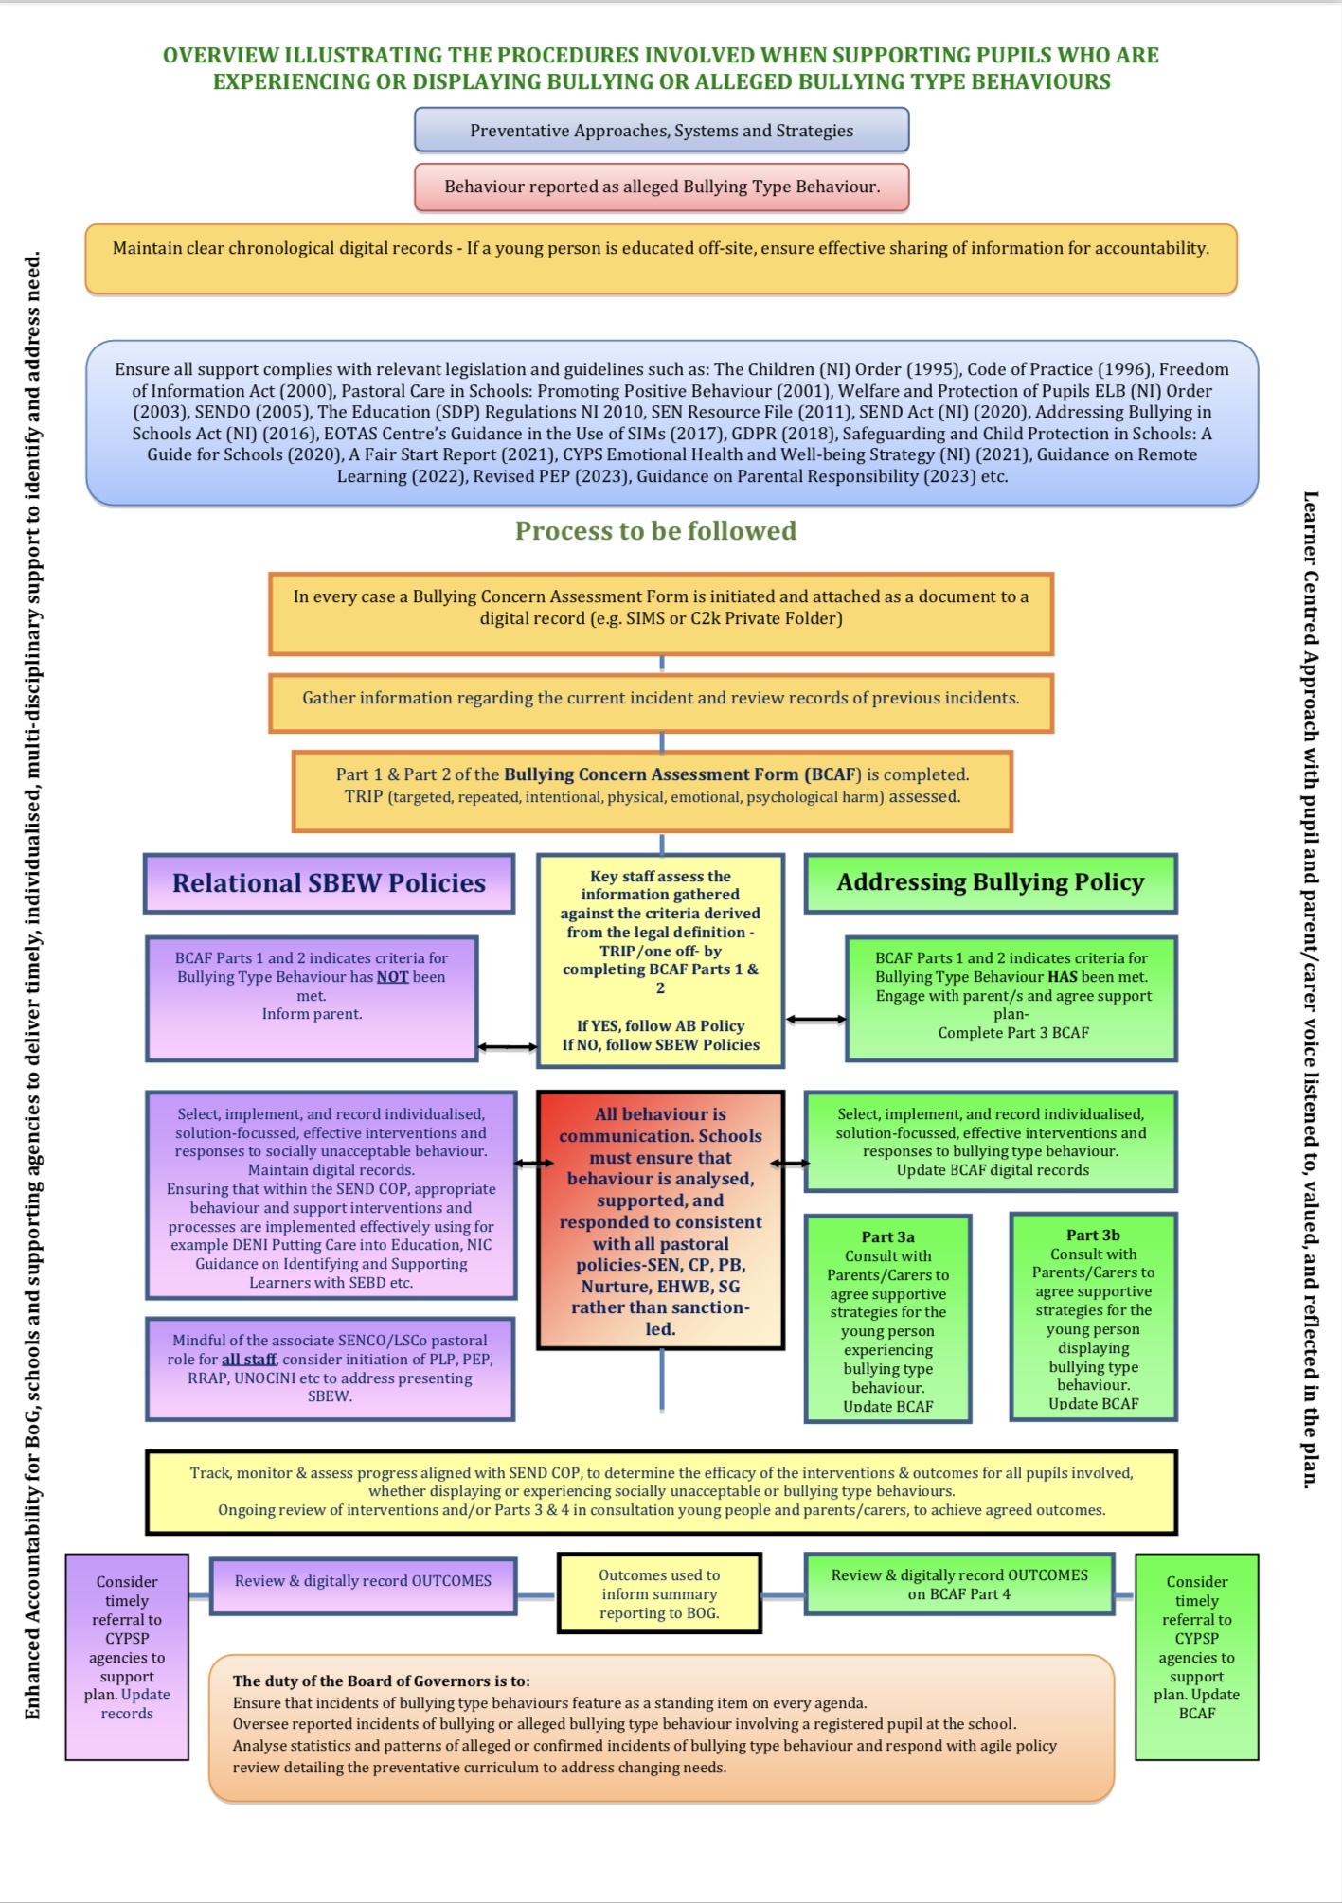

**Appendix 4**

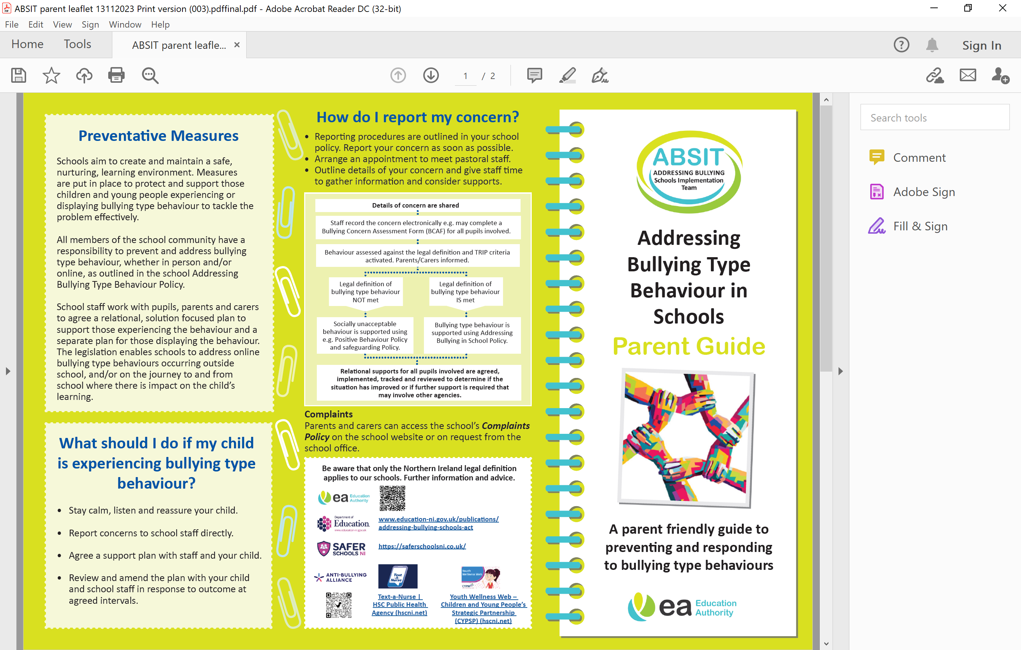

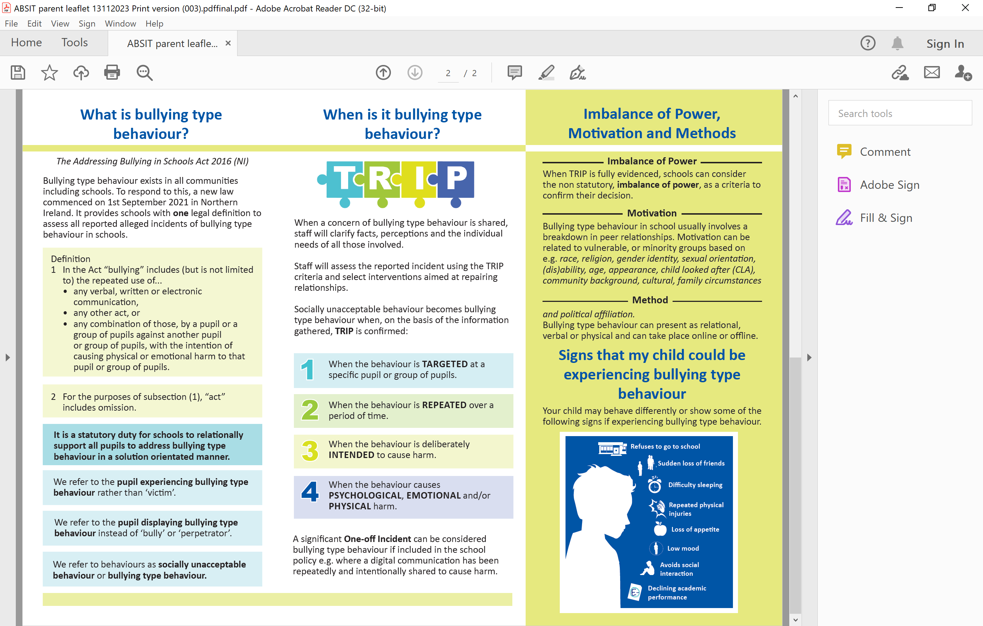

**Appendix 5**

