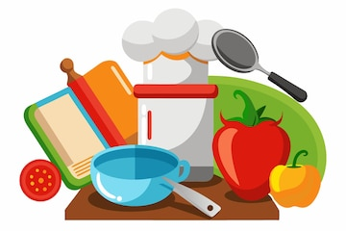Year 8 Home Economics Revision Checklist

Christmas Examination

|  |  |  |
| --- | --- | --- |
| I Can: | 😊 | ☹ |
| Explain food skills. |  |  |
| Describe how to weigh and measure. |  |  |
| Outline the procedure for washing dishes. |  |  |
| List good personal hygiene practices. |  |  |
| Describe the need for safety in the kitchen and identify common types of accidents. |  |  |
| Outline safety rules for Home Economics. |  |  |
| Explain simple procedures for first aid. |  |  |
| Identify pieces of kitchen equipment and state their use. |  |  |
| Describe a range of electrical appliances used in Home Economics. |  |  |
| Explain the 3 method of heat transfer. |  |  |
| Outline the main parts of the cooker in relation to use and safety points. |  |  |
| Describe basic procedures for preparing and cooking food. |  |  |
| Describe what bacteria is and what is needed for it to grow. |  |  |
| Outline common types of food poisoning. |  |  |

Home Economics Department

Ballymena Academy