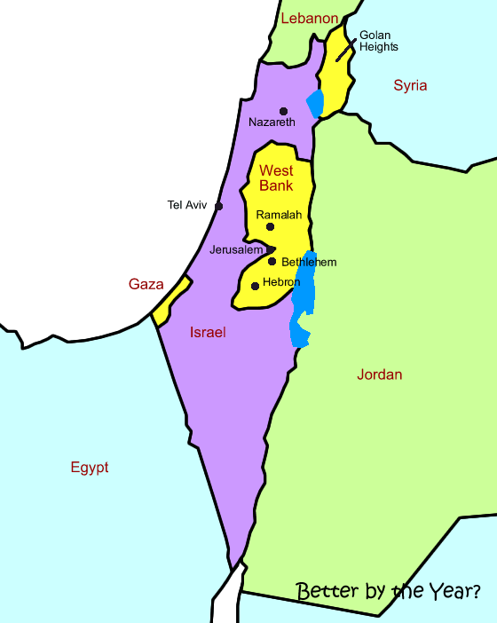
I will learn about the land of Palestine. I will look at its religious, historical, geographical and political background.

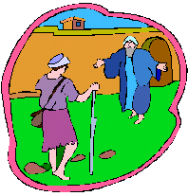
I will learn what about the life of Jesus. I will be studying his teachings, his miracles and his relationships with others.
http://www.angelfire.com/journal/althehare/pse.html
www.request.org.uk/main/bible/parables03.htm
www.request.org.uk/main/bible/miracles01.htm

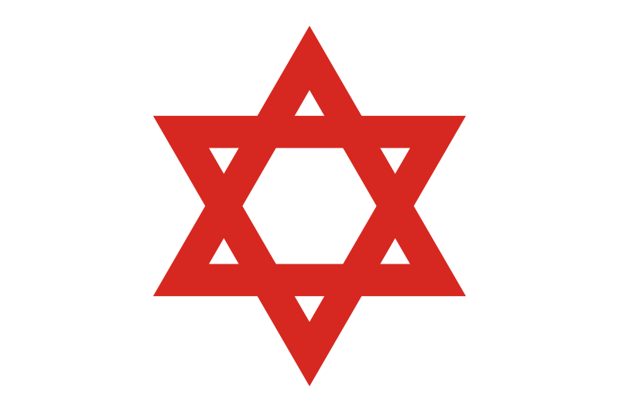

I study the Jewish religion. I will get the opportunity to examine the key beliefs and practices of the Jewish people.

http://www.bbc.co.uk/religion/religions/judaism/

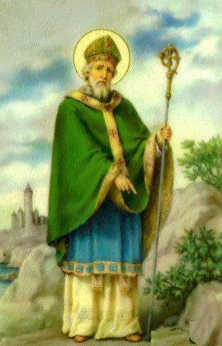
I will study the life of St Patrick. My teacher will take me through his early years, his capture, his life on Slemish Mountain and his call back to Ireland.

http://www.bbc.co.uk/religion/religions/christianity/saints/patrick_1.shtml

YEAR 9 STRETCH AND CHALLENGE
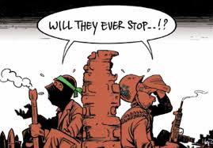

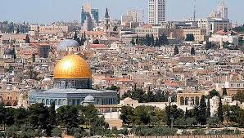

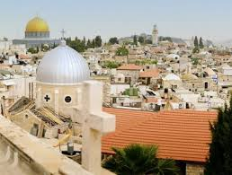

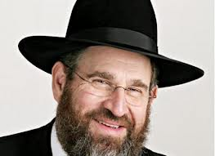
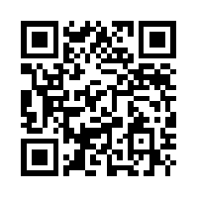
Module 1 – Palestine
3
4/5
4/5
10
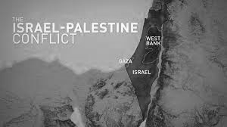

3
4.

Module 2 – Life of Jesus
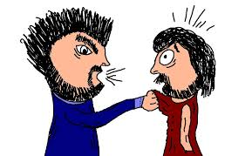

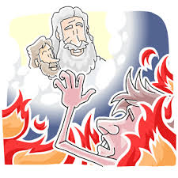

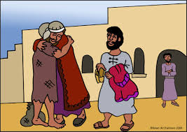



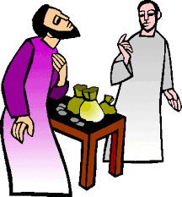

5
6
9
10
3
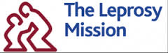

8/9
8/9
12
5


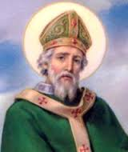
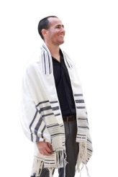

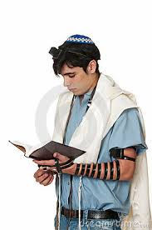

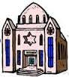

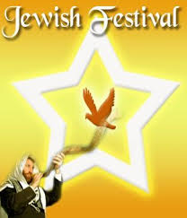

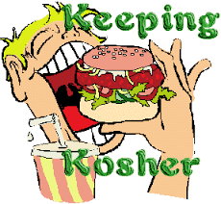

Module 3 – Judaism Module 4 – Saint Patrick
1
6
6
9
11
12

YEAR 9 STRETCH AND CHALLENGE

Module 1 – Palestine

3. Conflict in Palestine 1 =
http://www.youtube.com/watch?v=IQ9QtsRGxp8

3. Conflict in Palestine 2 =
http://www.youtube.com/watch?v=vScdqg8r9GE

4/5 Palestine excellent tour =

http://www.youtube.com/watch?v=BnaqsMHYGiI

4/5 Rooftop Jerusalem =
http://www.youtube.com/watch?v=DcqSeZ9eOf4

10. A rabbi's view on Jesus =
http://www.youtube.com/watch?v=iKBPWCdNVZw

Module 2 – Life of Jesus

5. The Unforgiving Servant (modern Day ) =
http://www.youtube.com/watch?v=7NUVnyo7O0w
6. The Rich Man and Lazarus =
http://www.youtube.com/watch?v=tyHoKj05Ll4

9. The Prodigal Son =
http://www.youtube.com/watch?v=QpXWbNjCV4w

10. Debate on miracles =
http://www.youtube.com/watch?v=urvkaWdSlUw

3. Calling of Matthew =
http://www.youtube.com/watch?v=TpdOmTeoYNw

8/9. The Leprosy Mission =
http://www.youtube.com/watch?v=v9nN22Fek58

Module 3 – Judaism

6. Tallit =
http://www.youtube.com/watch?v=2spIYDkm27o

6. Tefellin =
http://www.youtube.com/watch?v=yWXwcIh1zv0

9. Tour of a synagogue =
https://youtu.be/j0CuPBZJiQA

11. Jewish Festivals =
http://www.youtube.com/watch?v=1z8ce46Bt2o

12. Kosher =
http://www.youtube.com/watch?v=oJMmDoGMoPI

Module 4 – Saint Patrick

- Saint Patrick's Day =
http://www.youtube.com/watch?v=Ni5TcghNpak

