**Year 8 Big Picture**

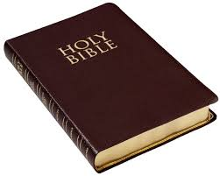**The Bible**

* Study the Bible as a library and as the word of God.
* Look inside the Bible to see what it says about itself.
* Compare different translations and investigate why the Bible is so important for Christians today.

**Creation**

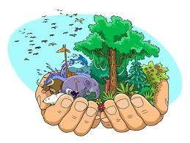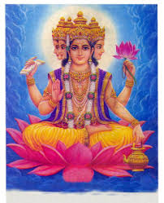

* Study three different creation stories: Christian, Chinese, and Hindu.
* Consider what the Bible says about God making the world in seven days.
* Explore what it means to be made in God’s image.
* Look at the Chinese and Hindu creation stories.
* Compare each creation story and discuss the similarities and differences between them.

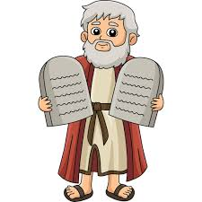**Key Biblical Figures**

* Study six key biblical figures: Adam and Eve, Abraham, Moses, David and Elijah.
* Look at each figure and consider why they are important in Christianity
* Look at the idea of a ‘calling’ or ‘vocation’ by looking at modern day examples.

**Respect**

* 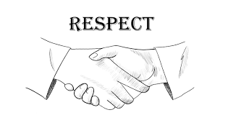Explore how we can have respect for others.
* Look at the key definitions of discrimination, prejudice and racism.
* Study the life of Nicky Cruz and his struggles with violence and crime.
* Explore how we can respect the environment.
* Calculate our carbon footprint.